**PROJECT ARCHITECHTURE DETAILS**

* Project Name - EBank_App
* FrameWork used - .Net Framework version 4.5
* DataBase Used - SQL Server (Any version—preferred 2017)
* Frontend Design – Designed with using Razor View Engine
* Naming Convention – camelCasing (for e.g. FindCustomer class should be written as findCustomer.cs )
* Design Pattern **-** Repository Pattern

**Step By Step Guidelines**

1. 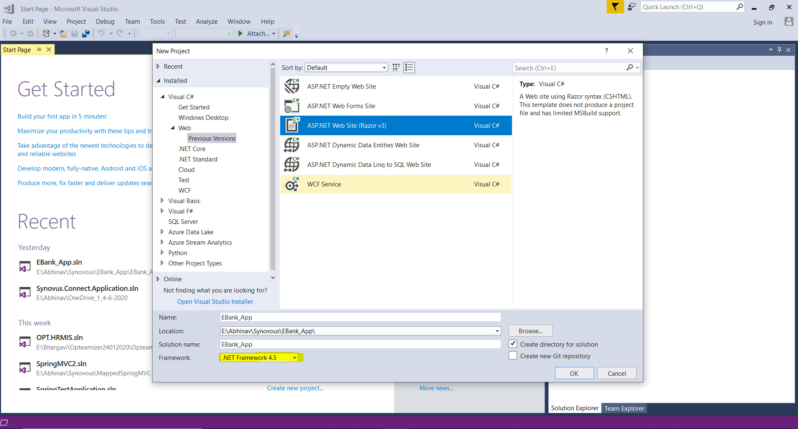Creating a new Visual Studio Solution file with name as given and selecting the previous version of web framework as shown in the image
2. Also the selected site design is ASP.Net Web Site (Razor V3).
3. The solution will look like this 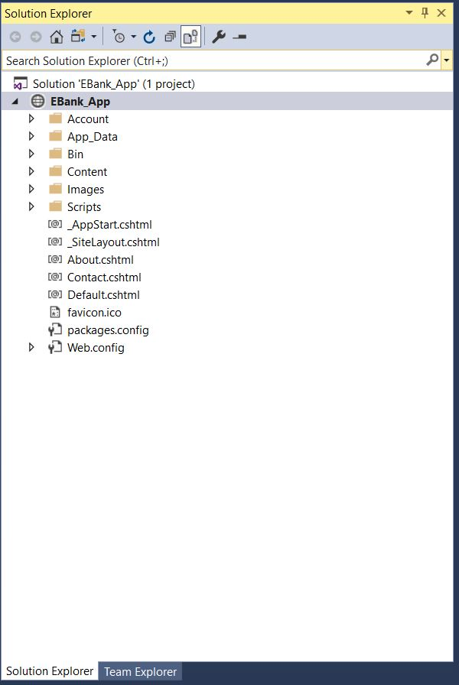
4. Add 4 layers or four different folders in it namely -   
   BizLayer, DataLayer , Presentation Layer, Service Layer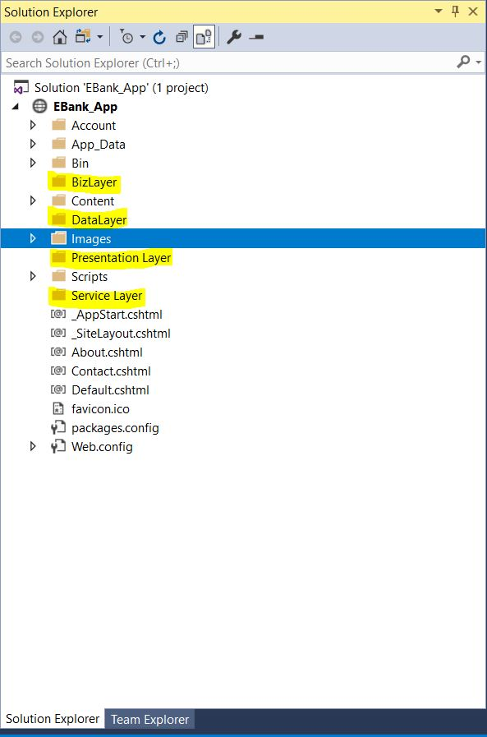
5. **Presentation Layer** contains mostly the classes having views ,   
   **Biz Layer** contains mostly the Logic Part for a particular method , **Service Layer** contains the interfaces and services (if required) ,  
   **Data Layer** contains the data connection entities.
6. All the interfaces to be written followed by Capital “**I**” and all the methods present in your module should be declared in it.
7. We are trying to mimic “**Money Order**” functionality , so we can divide our work and firstly we have to download this project from the github url (‘<https://github.com/Abhinavopteamix/EBank_App>’).
8. The home page itself should contain two parts in the left portion we have to merge “**Find Customer by Card**” functionality and in the right portion we have “**Find Customer by two Mandatory Fields**” functionality.
9. On clicking of “**Find**” button provided in the page the user should be able to view the customer details at the bottom, similar to Synovous Connect display result.
10. The mandatory fields includes “First Name, Last Name, Phone Number, DOB” , the user can enter any two of them and click on find to display the result.
11. The result should display unique info as in this case (Last Name, DOB,Phone Number)
12. The display Name in the result will be a hyperlink , on clicking of which the user will be redirected to employee details page containing the complete info of the customer. (”**Customer Details Page**”)
13. Left side of the same page contains link to “Money Order” , on clicking of which user will be redirected to “**Money Order Page**”
14. Money Order page contains info about the current amount user has and also options how much amount user wanted to do Money Order
15. On Successfully completion of the transaction , it will display “Money Transferred Successfully”
16. That particular amount will be deducted from the person’s account and the remaining amount is shown after that.

**DIVISION OF WORK**

1. Find Customer Via Card Number – Madhu
2. Find Customer via Mandatory Fields – Kishore
3. Home Page (Contains these two functionalities merged) – Abhinav
4. Authentication and Result Display on Home Page – Abhinav
5. Customer Details Page – Kishore
6. Money Order Page Design – Madhu/Kishore
7. Money Order Page Logic and Transaction – Madhu/Abhinav
8. Successful Transaction & Logout - Kishore